Project Design Phase-II
Data Flow Diagram & User Stories
Date | 19 July 2026
Team ID | [Fill in your Team ID]
Project Name | Book A Doctor – Online Doctor Appointment Booking System
Maximum Marks | 4 Marks

Data Flow Diagram
A Data Flow Diagram (DFD) is a visual representation of the information flows within a system. It shows how data enters and leaves the system, what changes the information, and where data is stored. The Level-0 DFD below shows Book A Doctor's three external entities (Patient, Doctor, Admin) interacting with the central booking system, and the three core data stores it reads from and writes to.
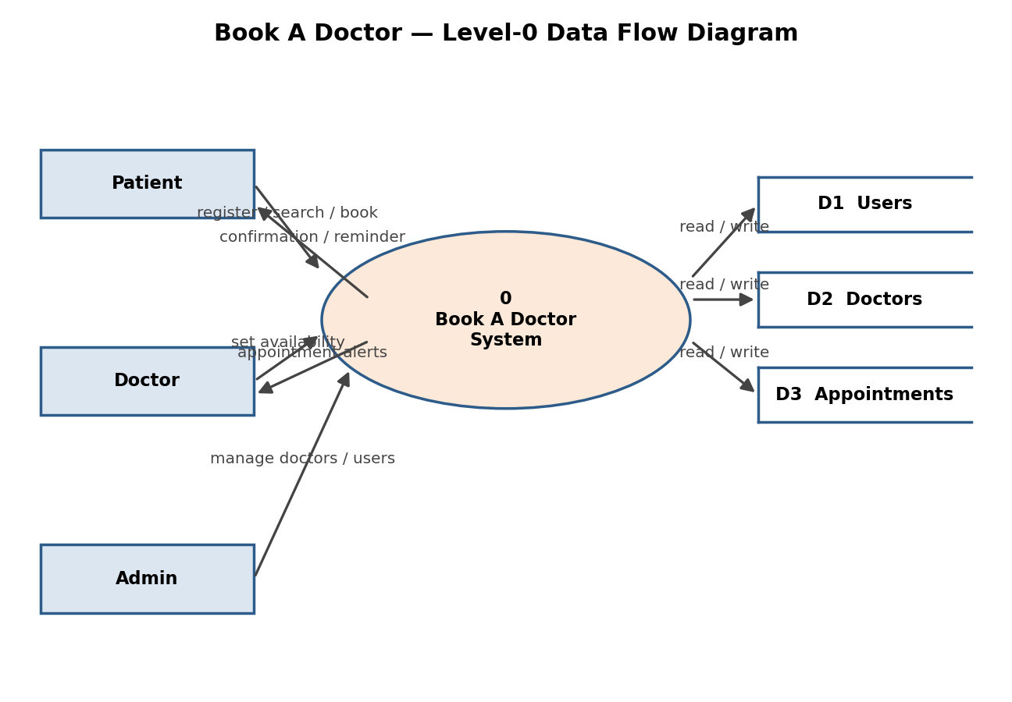
User Stories
The table below lists user stories for each user type, grouped by epic, with acceptance criteria, priority, and target sprint.
User Type | Epic | Story # | User Story / Task | Acceptance Criteria | Priority | Release
Patient | Registration | USN-1 | As a patient, I can register by entering my name, email, and password. | I can access my dashboard after registering | High | Sprint-1
Patient | Registration | USN-2 | As a patient, I receive a confirmation email after registering. | I receive and can click a confirmation link | High | Sprint-1
Patient | Login | USN-3 | As a patient, I can log in with my email and password. | I am redirected to my dashboard on success | High | Sprint-1
Patient | Doctor Search | USN-4 | As a patient, I can search doctors by specialization and location. | Matching doctors are listed with fee & rating | High | Sprint-1
Patient | Booking | USN-5 | As a patient, I can view a doctor's available slots and book one. | Slot is reserved and no longer shown to others | High | Sprint-2
Patient | Booking | USN-6 | As a patient, I receive a confirmation and reminder email for my booking. | Email arrives with date, time, and doctor name | Medium | Sprint-2
Patient | Booking | USN-7 | As a patient, I can cancel or reschedule an upcoming appointment. | Slot is released and status updates instantly | Medium | Sprint-2
Doctor | Onboarding | USN-8 | As a doctor, I can create a profile with specialization, fee, and available slots. | Profile appears in patient search results | High | Sprint-1
Doctor | Dashboard | USN-9 | As a doctor, I can view all upcoming appointments in one dashboard. | List updates in real time as patients book | High | Sprint-2
Doctor | Dashboard | USN-10 | As a doctor, I can mark an appointment as completed or cancelled. | Status change reflects on the patient's side | Medium | Sprint-2
Admin | Management | USN-11 | As an admin, I can approve or remove doctor profiles. | Removed doctors no longer appear in search | Medium | Sprint-3
Admin | Monitoring | USN-12 | As an admin, I can view platform-wide appointment statistics. | Dashboard shows total bookings & active doctors | Low | Sprint-3

